The RDM-p Manual

Dr Ramesh Mehay, Programme Director (Bradford GP Training Scheme), www.bradfordvts.co.uk
Please note: the RDM-p approach is the intellectual property of its creator, Tim Norfolk. Permission grants should be sought from him (not me!). I would like to thank Tim Norfolk and Dr. Ruth Nisbet for reviewing this document and suggesting some significant changes.

This document is a comprehensive manual detailing the RDM-p approach. It is intentionally long to ensure clarity. By the end, it is hoped that you will be able to apply the RDM-p approach in practice.

The RDM-p model is a diagnostic framework to help guide your support for any trainee, but especially when you have one in difficulty. It was developed in 2006 by Tim Norfolk, an independent occupational psychologist with extensive experience of working with doctors in difficulty, including ones referred through the National Clinical Assessment Service (NCAS)^{*1}. Tim developed this new model of performance assessment because he found existing models lacked sufficient range or structure.
^{*1}NCAS is an organisation that promotes patient safety by providing confidential advice and support to the NHS in situations where the performance of doctors and dentists is giving cause for concern.

The RDM-p model has recently been adopted by the RCGP as the framework within which clinical and educational supervisors are asked to report on all trainees. The 12 Work Based Assessment domains fit neatly within Tim’s model, but it has a particular value as a tool for diagnosing patterns in the performance of trainees in difficulty.

I am confident you will find this comprehensive guide helpful. I’ve quoted snippets from the original published paper, which is referenced at the end². A number of my observations below are taken from notes I compiled when attending Tim’s specialist course on this challenging area of our work.

Why should you read this document?
Many of you will be able to recall moments when a trainee of yours has begun to have performance problems. Unfortunately, what most of us tend to do at that point is to dive in, make some superficial guesses at the causal factors and then spend the rest of our energies trying to fix them: a method which is fundamentally flawed and prone to failure because we have not thought through things properly. The RDM-p approach stops you from jumping to conclusions and makes you define the performance concerns properly before trying to solve them.


You should read this document if:
- You’ve got a trainee in difficulty and don’t have a clear way forwards.
- You’ve had a trainee in difficulty and didn’t really know what to do.
- You have tried other frameworks which have failed you and your trainee.
- You want to read about a model developed by someone who deals with trainees in difficulty on a regular basis (I’m referring to Tim here, not myself).
So, why look at this approach?

There are a number of models out there proposing how you should ‘deal’ with a trainee in difficulty (like CLMDA³), but many blur the boundary between diagnosing what the problem actually is and what is causing it (‘symptoms and cause’). You need to keep the two separate, and the RDM-p model does just that.

Here’s a summary of what is so great about the RDM-p model:
- The central part of the process is to ensure an accurate diagnosis of the problem first (through the RDM-p framework). Only then do you start a step-by-step search for causes (through the SKIPE framework which we will explore later). Separating performance (RDM-p) from the causal/influential factors (SKIPE) makes you tease out distinct and meaningful real performance areas of concern.
- RDM-p makes you start with the evidence about the trainee rather than making subjective judgements on what a few people have said. It encourages you to collect and examine comments (from the trainee and others around them) based on observed events. This is more likely to point you in the right direction than the stab in the dark approach offered by other methods. Other methods usually provide a ‘rough and ready’ template going through common areas of difficulty.
- Other approaches consider a less coherent range of causal factors. Through SKIPE, the RDM-p approach makes you consider causal and influential factors; it is therefore more comprehensive and methodical.
- Most other models are deeply flawed because they get you to look at each individual causal factor in isolation (i.e. as separate entities). In real life, underperformance is a result of several causal and influential factors interacting with each other – this is at the heart of the RDM-p approach (explored through SKIPE).

Diagnosing the problem: through RDM-p
The RDM-p approach reminds us that the quality of the outcome is determined by the quality of the input. Therefore, it’s important to spend time gathering data. When you’re concerned about a trainee’s performance, your concerns usually stem from some sort of evidence (the data). Those bits of evidence might be:
- Something you have directly observed or noticed – for example, finding a whole host of letters in their room that have not been acted upon in a timely way.
- Something others have said - reception staff complaining how small the trainee makes them feel, a patient complaining about their attitude, your practice manager telling you how they always seem to be half an hour late for work.

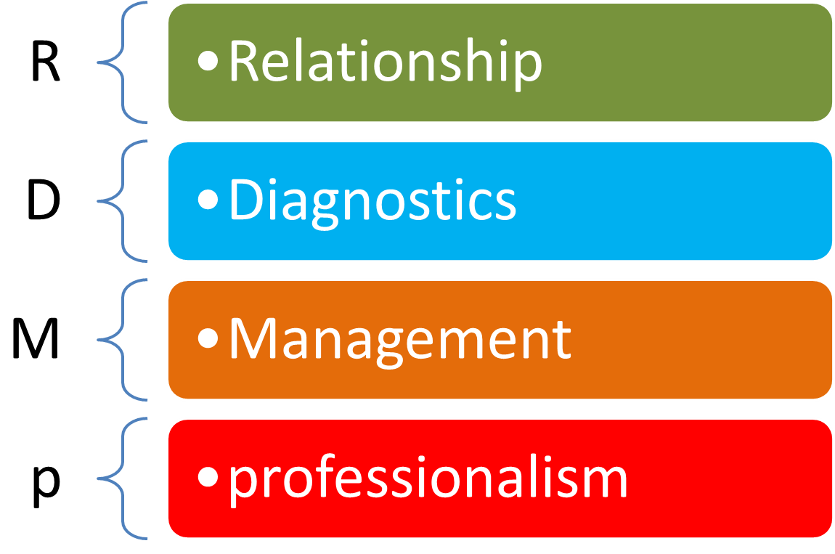
For the RDM-p model to work, it’s important you collect as much of these specific bits of ‘evidence’ as you can. However, rather than jumping to conclusions at this point, the model gets you to map these bits of evidence to particular areas of performance concerns. Generally speaking, a trainee’s underperformance (in the context of patients, colleagues, others or themselves) will fall into one or more of the four RDM-p areas (see diagram right):

- Problems with building or maintaining relationships – with patients, colleagues or others.
- Problems with diagnostics – this could relate to gathering or interpreting information, prioritising or decision-making (not just clinical, but in making decisions for other parts of their lives too).
- Problems with management – management in this sense relating to organisational management rather than in the clinical sense. Things like organising their work, themselves or others.
- Problems with professionalism – as in attitude, honesty, integrity or trust.

Mapping the evidence in this way helps you to generalise away from the specific and thus helps you build a clearer picture of where the performance difficulty lies. The true nature of the difficulty begins to emerge through reviewing all four RDM-p areas and seeing where the densest negative evidence seems to lie. In their paper, Norfolk et al² say:

In essence, general practice involves a subtle interaction between three core activities: relationship, diagnostics and management. They could perhaps be visualised as three interlocking ‘cogs in the wheel’, for which professionalism then provides the essential oil. Within the dynamic interaction between these three areas lies every component of the job, though most attention centres on relationship and diagnostics.

Diagnosing the causes: through SKIPE
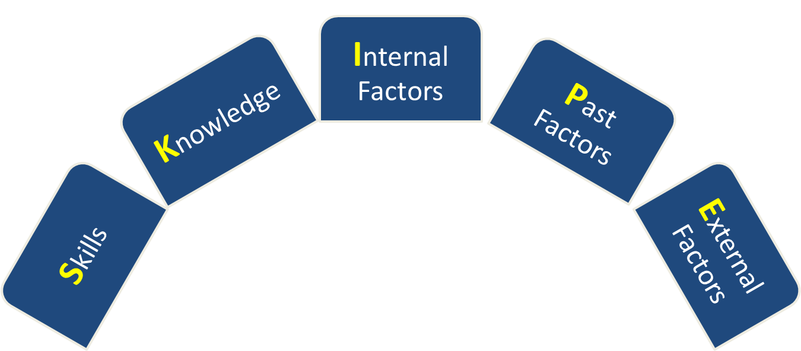
Once you’ve identified which of the four performance domains are problem areas, you then need to explore the causal factors that lie behind them and the influential factors that may be maintaining them. This exploration can only be done in discussion with the trainee. The RDM-p model again provides a structured and comprehensive way to do this – through something called the ‘SKIPE’ framework. SKIPE stands for Skills, Knowledge, Internal factors, Past factors and External factors.
SKIPE defines a set of causal and influential factors which can affect an individual’s development in any of the three performance domains (Relationship, Diagnostics, Management), and can also affect the professionalism that underpins them.


The work SKIPE of course immediately echoes ‘Skype’ (for online communication), and the parallel is deliberate. Skype badges itself as a simple way to connect and facilitate discussion; SKIPE does exactly the same: as a way of establishing appropriate ‘connections’ between behaviour and its causes, and as a rich source of dialogue with an individual trainee.

The SKIPE framework is intentionally kept separate from RDM-p to emphasise the fact that trainers need to draw on the same principles that should guide clinical practice: searching first to diagnose the problem (via RDM-p) and only then searching for possible causes (via SKIPE).
The theoretical basis for SKIPE: read what follows in reference to the diagram below:

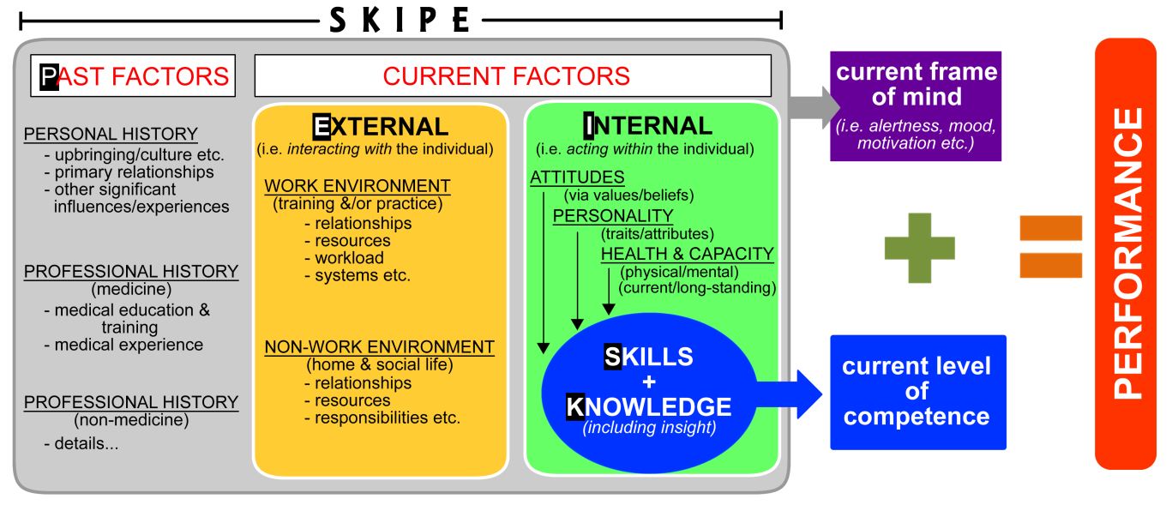

- Concentrate on the blue shapes for now: Competence is primarily defined in terms of a trainee’s knowledge and skills (i.e. what we can actually hear and see as they perform). If these are poor, a trainee is unlikely to have basic competence; you cannot perform well (red box) if you don't have the competence to do so! And what does the trainee need to be competent in? Ans - The three primary areas of performance defined in R, D and M. Hence it is these three areas that get first attention
- So when a trainee underperforms, we naturally tend to focus on strengthening their knowledge and skills (the blue oval), hoping that this will redefine and raise competence (blue box) and hence ultimately improve performance (red box). There’s nothing wrong with that; if a trainee does lack knowledge or skills, we clearly need to strengthen them. But the problem is that we tend to focus too narrowly on this – yet much of the story may lie elsewhere
- The other part of the story is embedded in the grey, yellow and green rounded rectangular boxes (the Internal, External and Past factors). These interact with each other to help determine a trainee’s current state of mind (the purple box), as well as potentially influencing the development of knowledge and skills (the blue oval). It is this moment-by-moment ‘mindset’ (the purple box) that mediates the relationship between current competence (the blue box) and performance (the red box). Therefore, it’s imperative that we consider these other rounded rectangular boxes if we are serious about adopting a comprehensive or holistic approach.

- Internal factors: These are factors currently acting within the individual like attitudes/values, personality traits/styles and health/capacity. The trainee’s attitudes will largely determine their professionalism. Problems here should signal you to revisit the ‘p’ evidence for clues. (N.B. Be careful if you are thinking of using personality questionnaires: they certainly measure general tendencies, but can become blunt instruments when we look closely at particular circumstances in which an individual is struggling. In this context, such general measures can become unreliable.)
- Past factors: These are the foundations on which individuals build their professional life; it considers both early influences (such as upbringing, cultural and educational roots) and more recent influences (such as their experiences in training practices and hospitals). Any of these could be having a dominant or lingering effect on an individual’s thinking and behaviour. Many of our distinctive personal traits will derive from particular influences in our upbringing. So if you notice for example that your trainee displays characteristics such as perfectionism, or a chronic lack of confidence, or strong values based on ‘right and wrong’, these will often have their roots in deeply established patterns of thinking or living instilled by others. When exploring causes it can be very useful to touch on this with your trainee – though this needs to be handled sensitively. Such reflective dialogue can lead to important ‘light-bulb’ moments for trainees, often allowing them to temper the influence of particular traits once they realise their roots and impact.
- External (or ‘rogue) factors: These are factors currently interacting with the individual – either at home or at work (like relationships, resources and expectations). For example, a single mum trying to cope with two little ones and yet trying to stay on top of being a full-time GP trainee. Or an overworked trainer becoming frustrated with his ‘slow-to-learn’ trainee, which leads to a breakdown in their relationship, undermines the already fragile confidence of the trainee, and triggers stress-related symptoms (and unreliable performance) in the trainee.
- ‘SKIPE’ simply suggests the natural route through these various factors: First consider the level of skill being demonstrated & the knowledge underpinning it; then step back and think about other current internal factors that might be having an impact; then ask yourself whether any past factors might be having a lingering effect on the individual; finally check whether any external factors (‘outside the individual’) are messing things up further. Taking this approach, SKIPE gets us to look at factors potentially influencing from within the individual (whether current or in their past), and from without (i.e. external factors), and importantly invites us to consider them together. From here, appropriate development plans can then be created.
- If you prefer, think of it another way: we need to ‘SKIP’ through the various factors that help us understand the individual in themselves (how they generally think, feel and behave) and how this might be affecting their professional development. We then check the particular role External influences might currently be having on the individual’s thoughts, feelings and behaviour – and through this their development
Tim on SKIPE and causation
After diagnosis of the specific performance problem (through RDM-p), one starts the causal journey by testing the 'SK' evidence (RDM) to see whether an individual has ever demonstrated the particular skill or knowledge in question:
- If he/she has at some point, in some context, demonstrated that skill or knowledge (and we're therefore looking at a failure to apply existing skills in particular settings) then one embarks on the wider ‘IPE’ journey to discover what has caused the particular lapses in this case.
- If he/she never seems to have demonstrated the skill/knowledge, then the definitive cause may indeed lie here – making the IPE stages often a more cursory check rather than a deep exploration in search of a primary cause!

So the search for causation is always anchored by an initial 'SK' check. The best example of this in my work is when individuals are referred to me because of being 'doctor-centred'. The initial 'SK' evidence is in the consultation videos etc. (apparently "ignoring" cues or telling rather than asking etc.). Fine; that's the initial diagnosis of the problem. The key starting point for causation must then be to check the depth of their understanding about what 'patient-centred' consulting actually means. Time & again I work with doctors whose behaviour with patients has caused great frustration to trainers etc., yet they have never really understood what it means to deal with an individual rather than a problem! So the root of the causation is often also within the RDM (in this case 'D': the lack of understanding/insight into what they're supposed to be doing and therefore why what they are doing is perceived as rude etc.). Once they do understand, skills often begin to develop much more naturally. Hence one doesn't jump off into deeper issues until the 'SK' issues have been properly tested.

 | Top Tip: When someone is underperforming, tracking SKIPE won’t only reveal negative factors but some positive influences too (like good relationship skills, a strong work ethic, a supportive family). Accentuate these positives whatever else you feel needs to be addressed…

To summarise
- Three broad domains define the work of a GP (Relationship, Diagnostics and Management), all underpinned by professionalism. The RDM-p model helps you determine which of these is problematic for a particular doctor in difficulty
- Each of these domains demands a particular knowledge and corresponding skill set (the ‘SK’ of SKIPE), but their development may also be helped or hindered by wider factors (the ‘IPE’ of SKIPE).
- The key to using the model with struggling trainees is to first define what’s going wrong (using RDM-p). Only then try to determine what’s causing or influencing the problem (by searching the ‘SKIPE’ framework for clues). The SKIPE framework helps you to determine causal and influential factors with greater precision. As a result, you and your trainee will be in a better position to generate ‘remedies’ that are more likely to succeed.

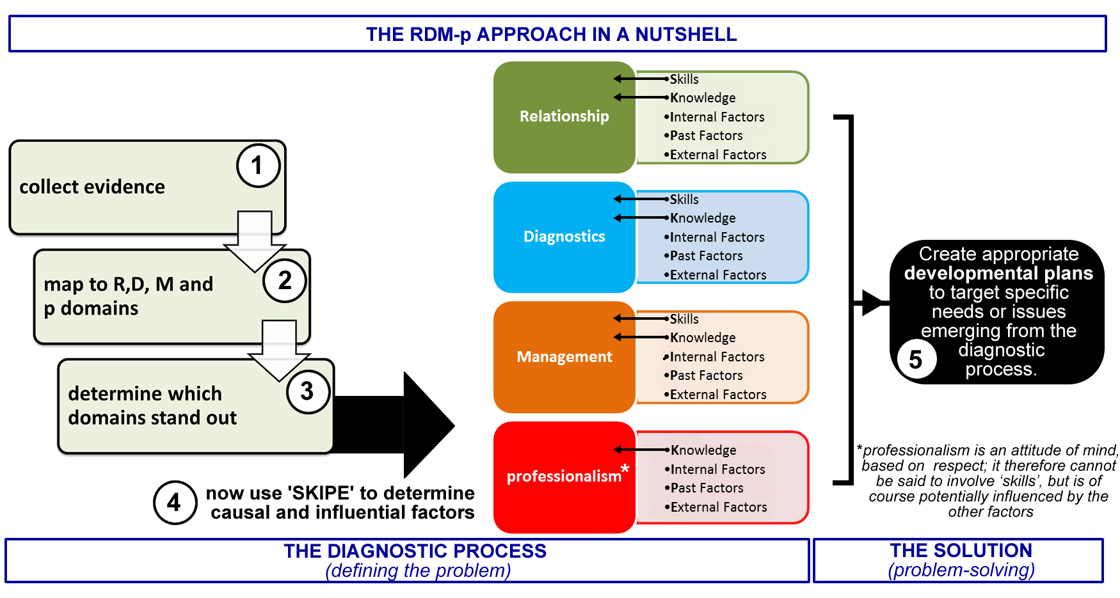

From here on, I’ll be talking about the ‘RDM-p approach’ – this is a short-hand way of describing the dual impact of using RDM-p then SKIPE to fully diagnose the ‘what & the why’ of underperformance. Only then can appropriate development plans be created to target the specific needs or issues emerging from the ‘diagnosis’.
The RDM-p domains in a bit more detail

Relationship
This examines whether there are any issues in the building or maintaining of relationship between the trainee and others (others being the patient, colleagues, staff, practice, hospital, colleagues and so on). So, we’re talking here about all verbal and non-verbal aspects of the way a trainee engages with others – mainly face-to-face, but also of course in writing.
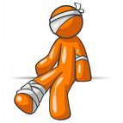
Signs & Symptoms of a Relationship domain concern:
Communication and consulting skills – like a lack of empathy, not adapting language and style to the circumstance, or not picking up and responding to verbal and nonverbal, or poor negotiating skills and so on.
Working with colleagues and in teams – not working in a team could be due to poor communication skills or delegation, but it might also be about leadership skills (encouraging or persuading people/patients to respond willingly or positively to one’s decisions or suggestions).

Diagnostics
This is where some point along the road to decision-making is problematic. It doesn’t just relate to diagnosis but also to data-gathering and prioritising of information. And the problem could relate to difficulties in making a decision about patients, colleagues, the practice, the hospital or oneself!

Deciding about oneself? For example, a trainee may have a problem in the Diagnostics domain if he or she doesn’t seek medical treatment or advice when their own performance or health is suffering. Thus accurate self-assessment (i.e. making a decision about oneself) is a vital part of day-to-day practice. A lack of self-awareness (or insight) usually points to a problem in the Diagnostics domain.
Signs & Symptoms of a Diagnostics domain concern:
Data gathering and interpretation – not doing enough of this for optimal decision making (whether for patients, colleagues, other staff or oneself)
Analytical skills – once the data has been gathered, difficulty in prioritising it or offering alternative options, suggestions or explanations
Decision making skills – where the trainee has a difficulty in reaching that pivotal point (imagine the peak of a triangle) where a decision has to be made; they are unable to draw together prioritised information in such a way that is clear, rational and defensible. For example, many of you might think procrastination must be a management problem (linked to poor organisation, perhaps) but very often it’s a diagnostic one – where someone struggles to DECIDE (or PRIORITISE) whether and when to do something, even though they have the time. Other examples include: not knowing when to treat, to refer, to wait and see or blindly ordering all tests under the sun.
Examination and technical skills (i.e. practical diagnostic skills) – not conducting examinations and tests (including medical instruments) in an appropriate manner.

In their paper, Norfolk et al² say the following about relationship and diagnostics

One of these activities is clearly internal (diagnostics), the other is external (relationship); together they determine the quality of much of our interaction with others at any given moment. For example, dealing effectively with a seemingly anxious or frustrated practice partner requires the same analytical skills, and similar communication skills, to dealing with a seemingly anxious or frustrated patient. We may have very different roles in the two conversations, which may demand adjustments in style and emphasis, but the basic skills are the same.

Management
We’re all used to the term ‘management’ in medicine: for example, the (clinical) management of COPD usually makes us think of the stepwise approach to managing COPD involving long acting B2 agonists, steroids and so on. RDM-p uses management in a more general sense: the on-going handling of one’s professional responsibilities, not only to patients but also to colleagues AND oneself. Management in RDM-p refers to the administrative and organisational side of things, the day-to-day personal routines and systems we work within rather than management in the clinical sense.

Signs & Symptoms of a Management domain concern:
Managing particular events – for example, a lack of structure to the consultation, not managing their referral letters or pacing a meeting badly.
Managing on-going events – like not maintaining adequate records after home visits, not keeping on top of one’s other roles within the practice, not keeping up with information management and technology.
Managing relationships – like not providing continuity of care or routinely monitoring one’s interaction with colleagues.
Managing oneself – for example not monitoring one’s own performance, learning and development; not establishing an effective work-life balance, or not keeping on top of one’s physical or mental health and well-being (e.g. no longer playing sport because you’re ‘too busy’, or ‘too stressed to relax’).

Question: Consider a trainee who has difficulty in the clinical management of patients. Would that be a Management issue or a Diagnostics one?

Answer: Actually it could be either or even both. If it is a ‘systems’ related issue (e.g. organising a referral) the difficulty is management. If it is a decision making issue such as prioritising a hierarchical set of treatments, the problem relates to diagnostics (a problem in deciding which order to put things in). Remember: a) a diagnostics problem can occur at any point along the journey to making decisions, based on moment-by-moment judgements; b) management is about on-going processes and structures. Each domain requires very particular knowledge and skills, so it’s crucial we first work out which of the two the problem relates to, or indeed whether it lies in both! This scenario illustrates the need to gather more information carefully and systematically, rather than jumping to conclusions and categorising immediate evidence too hastily.

In their paper Norfolk et al² say:

‘Management’, in this sense, describes an on-going process, for example providing clear structure within the consultation, pacing a surgery, organising one's time to balance visits alongside surgery and paperwork, monitoring one's own performance levels and health and so on.

The use of the term ‘management’ in this way, to suggest an on-going responsibility for applying diagnostic and relationship skills (as also implied by the term ‘manager’), can be and is widely understood and applied…

[Thus when ‘managing’ a consultation,] the doctor aims to structure or organise events so that a patient, however complex the presentation, can be dealt with efficiently and effectively within a given timeframe. The same would apply to managing one's thinking and decision-making through the course of a practice meeting, or managing one's work load on a specific day - thus, many individual diagnostic assessments being made at various points, and the process needing to be managed through efficient planning, organisation, structure and pace.

Professionalism
Professionalism is underpinned by qualities such as honesty, integrity and trust. It’s also enhanced by altruism (an unselfish concern for the welfare of others; selflessness). In more practical terms, we’re talking about having respect for people, maintaining an ethical approach to practice AND respecting one’s contractual responsibilities, which essentially boils down to respecting the three RDM-p performance areas: Relationship, Diagnostics and Management. Thus respecting the importance of: i) working fluently with others (relationship), ii) of following due process in gathering and analysing information (diagnostics), and iii) of meeting on-going responsibilities (management).
Signs & Symptoms of a Professionalism concern:
Respect for others – perhaps a trainee doesn’t appear to show equal respect for patients, colleagues, staff and others; for instance, being judgemental or not treating them equally.
Respect for one’s position – not acting within one’s professional roles/boundaries, not appreciating the effect of one’s behaviour/actions on others (e.g. running late and showing no regard for the poor patients who have been kept waiting), not minimising risk (e.g. where one’s own health might compromise someone else’s safety).
Respect for protocol – this isn’t just about failing to following clinical guidelines or local initiatives/policies but also about not adhering to established professional codes of practice. When someone doesn’t do referral letters in a timely way, it is clearly a management issue. However, it might also demonstrate a lack of respect to its importance; this lack of respect for process/protocol = a professionalism issue. This won’t necessarily be true in all cases - some individuals are disorganised, and need to develop better systems, but rush around desperately keen to do the right thing! They may therefore respect the idea of doing letters on time but can’t quite deliver. Discussing things with the trainee will help you determine which of these categories they belong to.

If one cannot answer the question ‘Am I doing what I should be doing?’ in the affirmative, then there is a problem in the professionalism domain. Let’s say you’re doing a Friday afternoon surgery and you’re running a little late. Professionalism is where you continue to do what is necessary for patients despite feeling pressurised, rushed and flustered: in essence acting responsibly, through respect for one’s position and the duties attached to it. A problem accurately placed in the professionalism domain means, by definition, that there is an attitudinal problem to be addressed by the trainee.

Norfolk et al² say:

What then determines much of the quality of the application of these [R, D & M] skills is the ‘professionalism’ that underpins them - defined here, in line with the profession’s typical emphasis, as commitment to and respect for, best practice.

... ‘a personal and professional obligation to strive for excellence, humanism, accountability and altruism’.
... ‘the professionalism is not defined by the behaviour, but the effort or commitment made in search of best practice in each given situation or context’.

We are speaking therefore of professionalism as a purposeful attitude, a positive and deliberate way of viewing or approaching one's work that will maximise the possibility of performing competently or better, whether in relationship with this or when working alone. Based essentially on this notion of respect for best practice, the quality of an individual GP's professionalism therefore depends on the value they attach to the various aspects of their job.

Put simply, if the professional value attached to any individual activity is insufficient, then the energy levels and attention to detail required to ensure that activity can be performed effectively will also be weakened, and the quality of performance will very often suffer.

Summary:
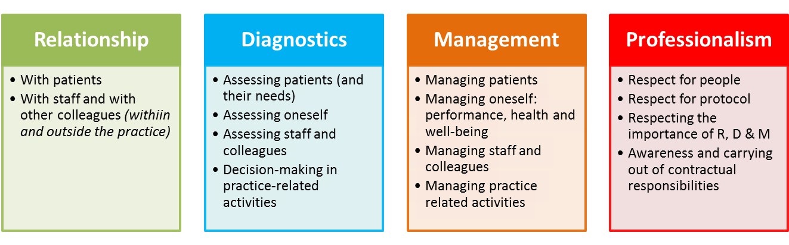
So three of these areas involve direct evidence of skill-based performance (Relationship, Diagnostics and Management) but the fourth (professionalism) is more indirect, focusing on an individual’s attitude to the RD&M areas. Professionalism is looked at separately because it is clearly not a ‘skill’, but a reflection of the approach taken to one’s work.

Norfolk et al² say:

General practice involves a subtle interaction between three core activities: relationship, diagnostics and management. They could perhaps be visualised as three interlocking ‘cogs in the wheel’, for which professionalism then provides the essential oil. Within the dynamic interaction between these three areas lies every component of the job, though most attention centres on relationship and diagnostics.

These four components of RDM-p together map the essence of any service profession: relate to someone, diagnose their needs, manage the process, and at all times ensure you act professionally.

The difference between general practice and many other services is that to be a ‘competent’ GP, all four elements need consistently to be demonstrated at high levels.

How MRCGP fits in with RDM-p

The MRCGP defines 12 competency domains all trainees must achieve before they can get their certification of competed training (CCT). The diagram below illustrates where each of these lie in relation to the RDM-p framework.

Please don’t let this diagram scare you. It’s a special kind of Venn diagram called an Edwards’ diagram and is easy to understand once you become a little more familiar with it. There are natural overlaps between all RDM-p performance areas. Venn diagrams are good for visually representing 3 or less intersecting data sets BUT RDM-p has 4 (R, D, M and p). It’s impossible to create a Venn diagram of four intersecting circles where each possible overlap of R, D, M and p are catered for. Don’t believe me? Have a go... for 4 data sets there are 15 possible permutations. The Edwards’ diagram below is a natural and intuitive way of displaying all the overlaps and it’s quite visually pleasing too. Edwards was inspired by a tennis ball (look at the red and blue outlines below). It’s basically an enhanced version of a Venn diagram. Venn himself pulled his hair out in trying to get four neat circles to do the same thing. The purpose of this diagram is to give you an ‘at a glance’ view of where things lie and their relationship to one another (thus helping you interpret the data more precisely).

RELATIONSHIP
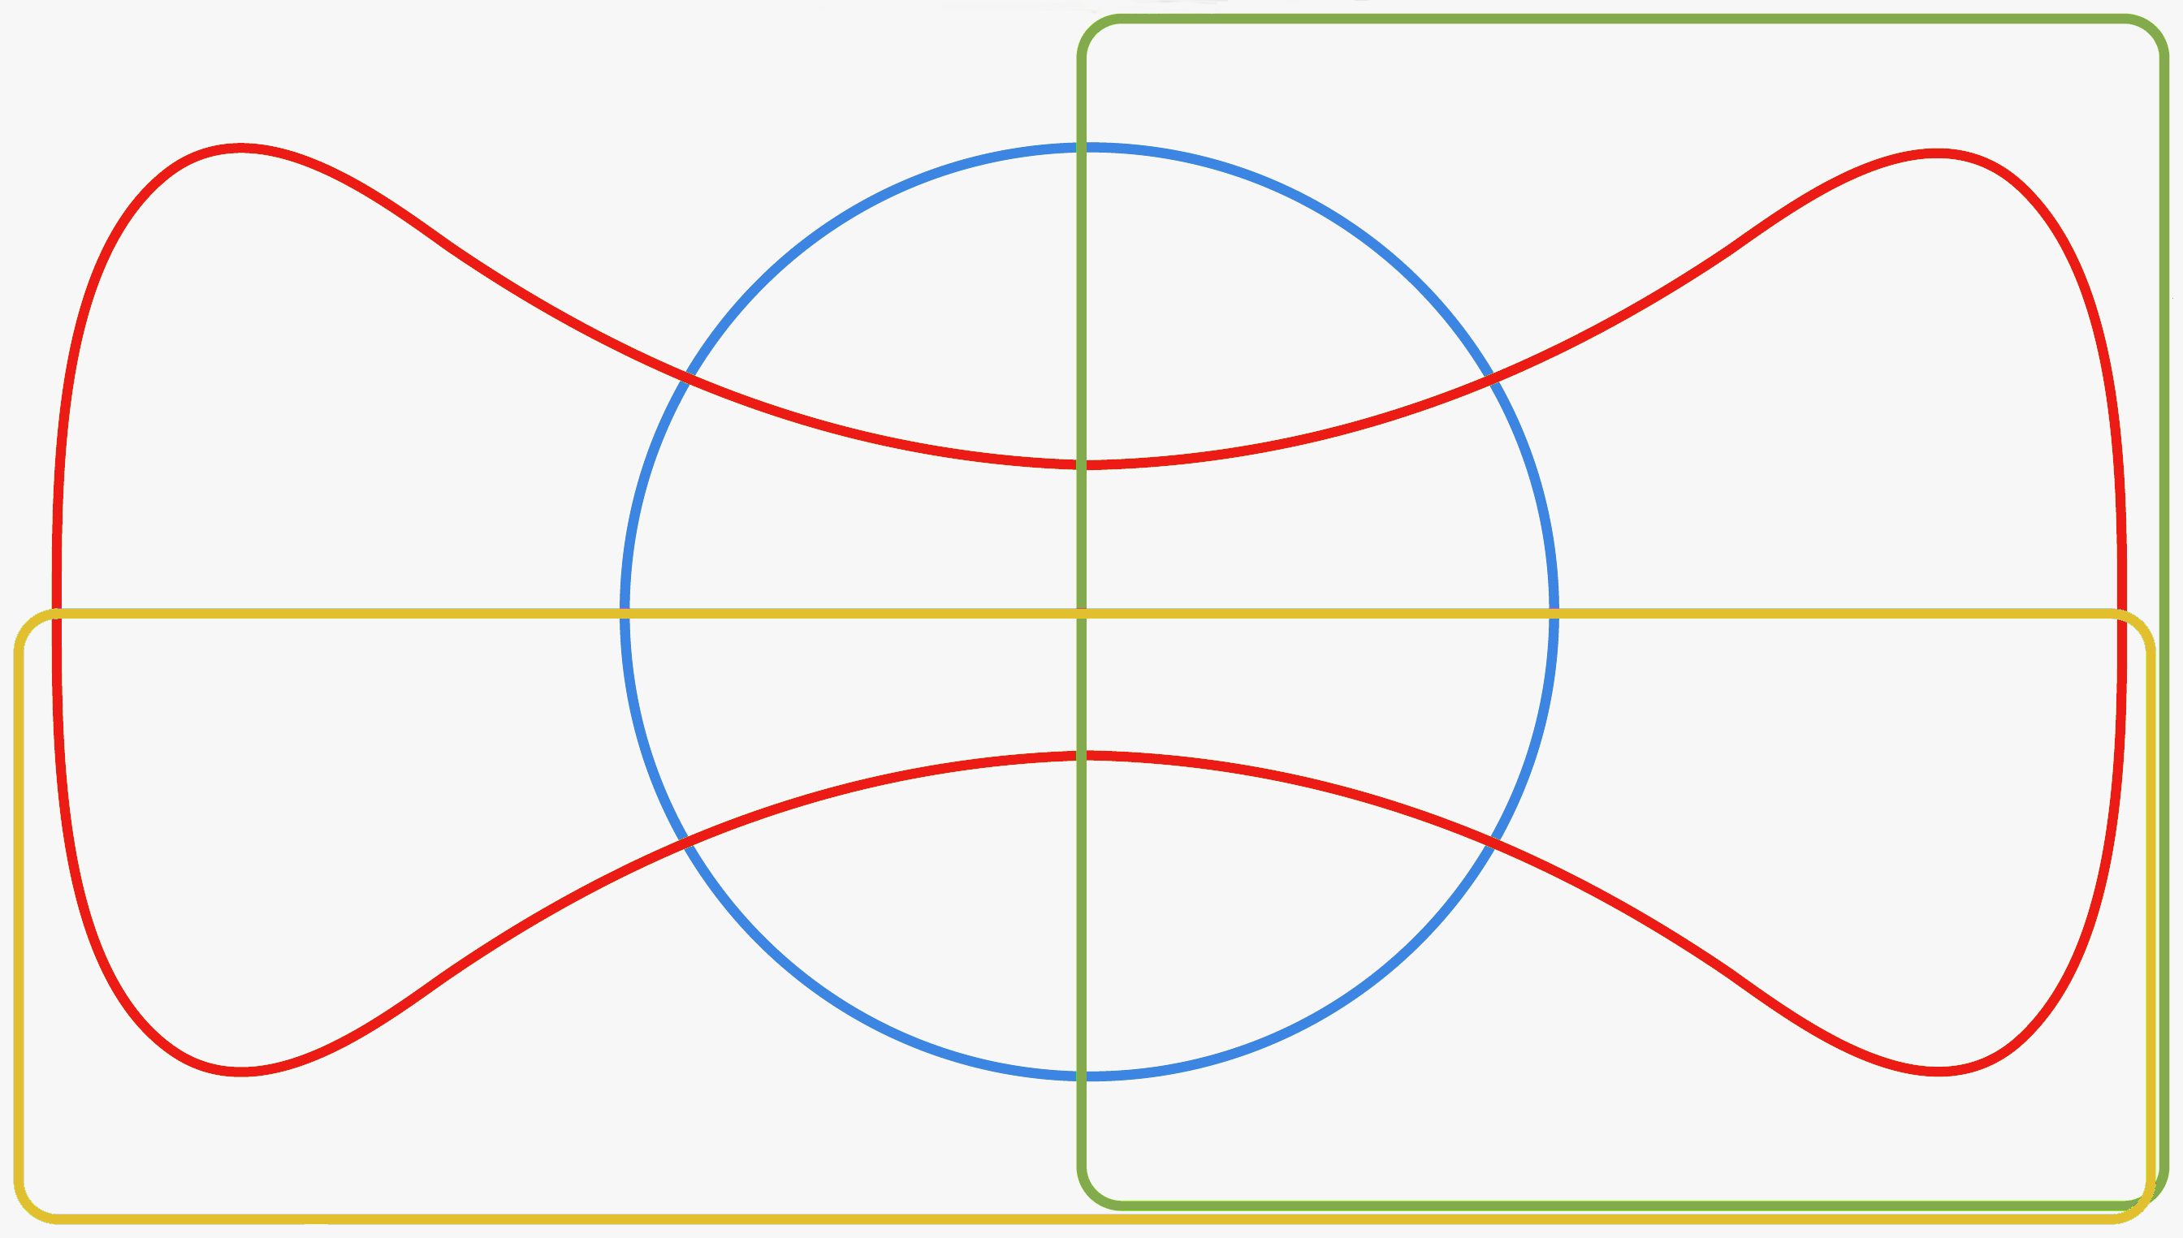
DIAGNOSTICS
PROFESSIONALISM
MANAGEMENT
practising holisticallyyy
Data gathering & interpretation
making diagnosis making decisions
communication & consulting skills
clinical management
managing medical complexity
maintaining an ethical approach to practice
fitness to practice
community orientation
working with colleagues & teams
Primary care administration & IMT
maintaining performance, learning & teaching

So, why are we showing you this diagram?
- The main reason is because we want you to get used to it. We will be referring to the Edwards’ diagram again later.
- Secondly, because we want you to see how the 12 MRCGP competency domains relate to each other and the RDM-p domains.
- Thirdly, to help you see the comprehensive coverage offered by the 12 MRCGP competency domains.
- Finally: because we want you to remember to refer back to it.

For instance, a colleague might say to you 'I thought I should let you know that after several surgery debriefs, I've got some concerns about Alan's clinical management of patients'.

Your first thought might be to presume Alan's knowledge is pretty poor, and that all you need to do is work on that (clinical knowledge is of course the fuel that drives the diagnostic process with patients). However, look at the diagram above and see where 'clinical management' lies. This should help you see that it is dangerous to jump to conclusions without thinking about things properly. Alan's problem might be
- A Diagnostics issue where he finds it difficult to come to a decision. Yes, Alan might be finding it difficult to make decisions because of a lack of clinical knowledge but equally, it might be due to other things like not gathering enough data in the first place to help inform the decision making process.
- A Management problem. Alan might be not clinically dealing with patients well because he feels pressurised for time in surgeries (because his consulting style lacks structure and often becomes rambling and repetitive). The primary problem might therefore not actually be a Diagnostics one. As a result, towards the end of most consultations he becomes doctor-centred and controlling without offering other options to the patient. In this instance, he has a problem with managing the consultation and managing himself! Indeed, the solution might therefore be to improve his knowledge and skills in relation to structuring the consultation rather than improving clinical knowledge!
So…
- Don’t jump to conclusions and remedies.
- Refer back to the Edwards’ diagram and think where the problem might lie.
- Always discuss things with the trainee to seek ‘the truth’.

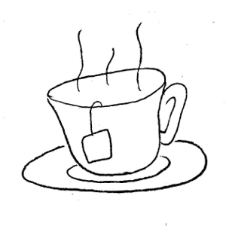
Relationship and Diagnostics is what happens at the coal face in general practice. Management helps to make that coal face happen. The Edwards’ diagram allows each discrete relationship between two or more of the RDM-p components to be established. It also gives professionalism its own space - its own ‘self-identity’. This underlines the fact that apparently illegal, fraudulent or dishonest behaviour does not necessarily have to have a link with R, D or M.

Now would be a good time for a break.
Then we’ll come back to putting RDM-p into practice.
The RDM-p approach in practice: Step by step

- Collect evidence from a number of different people (including the trainee) like:
- Verbal statements from others: A receptionist might say ‘He’s always late for his surgeries and even does his home visits very late... Patients ring up wondering where he is.’ Another doctor might say ‘Patients come out asking whether he’s always grumpy like that.’
- Written statements from others: A patient complaint for instance or multi-source feedback (encourage the trainee to do this if not already done).
- Things you have noticed: This may be knowledge, skills or attitudes. Record the specifics of the event that gave cause for concern.
- Things the trainee has noticed that they have difficulty with.
Don’t do anything with this evidence just yet – simply collect it. Write each piece of evidence on a separate line.
- Examine each piece of evidence (or statement) and figure out which of the four RDM-p domains it possibly relates to. Most items can be mapped to more than one of the four areas. Mark the statement with one or more of the letters R, D, M or p. Put a ‘+’ sign next to it if it is a positive indicator of that domain (i.e. positive evidence) and a ‘-’ if a negative one (i.e. a criticism). Put a domain in brackets if you think the evidence may be a weak (positive or negative) indicator of it. For example:
M- p- | ‘receptionists have said that he’s always late for his surgeries and even does his home visits very late – patients ring up wondering where he is’
R- D+ M- p- | ‘some of the doctors have said that, although he’s good at diagnosis and making decisions, patients have asked whether he’s always grumpy’
Don’t worry for now why I’ve put e.g. ‘p-’ for the first example or ‘M- p-’ for the second. The worked example at
the end of this chapter will make this and the whole mapping process a lot clearer.

Quick Tips: I only mark the positive ones with a plus sign and assume everything without a ‘+’ is a negative: looks less messy and it is easier to delineate/digest the positive from the negative. Tim has a system using 'highlighters' e.g. Relationship is green, so he underlines positive comments, highlights through negative statements, and circles the statement if it's 'about' relationship in a general sense.

- Step back and review your collated evidence as a whole and the RDM-p areas you have linked them to. Mapping it out on an Edwards’ diagram will make it easier to interpret the data as a whole. Determine which RDM-p domain(s) have the most evidence mapped to them.

- Meet with your trainee. Let them digest what people have written, then invite them to comment. This is vital, to ensure there is agreement about exactly what has happened. If the trainee challenges the supposed evidence, then this needs exploring carefully – otherwise your chances of later agreeing causes and finally reaching a shared plan of action will be greatly reduced…

- Using the SKIPE framework (Skills, Knowledge, Internal factors, Past factors & External factors), again explore with the trainee what might be causing, influencing or maintaining the performance problems identified in the R, D, M domains, and any related Professionalism issues.

- Finally discuss ways of making things better. Be specific and try and get the trainee to problem solve and generate solutions. For more detail, see the section below on ‘The discussion with the trainee’.

The discussion with the trainee
Before going any further, let’s just remind ourselves of one essential step in diagnosing causes: the individual trainee MUST be interviewed at the heart of this process, and in a non-judgemental way that allows apparent evidence about a problem, and its causes, to be qualified after weighing the trainee’s perspective against the views expressed by others.

The discussion has two purposes:
- For you and the trainee to accurately build a picture together (data gathering).
- To generate workable solutions that likely to have greater impact (management).

The RDM-p approach should parallel the principles of ‘good consulting’ – in essence, it’s a similar journey and the skills involved are similar – building rapport, data gathering, defining the problem, formulating a joint agenda, shared decision-making, joint future planning and so on. In summary, it should be:
- Person-centred
- Systematic and thorough
- Fair and respectful.

Being person-centred, fair and respectful means involving the trainee as much as possible from the start, just as you would involve a patient in the management of their own problems. Trainees are often the last ones to be informed and involved about their difficulty – this is a sure recipe for disaster. Involve them as early as possible – perhaps before or at the same time you talk to others (like colleagues, staff, programme directors). Don’t engage in detailed dialogue without allowing things to sink in. Let them see in advance the sheet where you have collated all the evidence. Give them some time and space to digest and reflect on the situation. This encourages self-evaluation. Be respectful of what they say and encourage a true two-way dialogue. If you share the difficulty and formulate a joint agenda/plan, you have the best chance of making real progress.

Being systematic and thorough means spending time gathering information and exploring it. Remember: The quality of the outcome is determined by the quality of the input. Good information gathering maximises the possibility of an accurate differential and working ‘diagnosis’, which in turn maximises the possibility of shared decision making en route to a functional management plan.

If you can consult with patients in a person-centred respectful way, then you have all the skills for helping a trainee experiencing difficulty using the RDM-p approach. And don’t forget – one of the purposes of the discussion is to build a picture of ‘the truth’. Therefore, at the data gathering stage, just because someone says something about somebody else doesn’t mean you can generalise that into a truth. Bear in mind who is right. For example, let’s say person A thinks person B lacks insight. Yet person A might lack true insight about the situation and B’s role in it. Sometimes person A can be a bit ‘trigger-happy’, not too fussed about making a careful assessment – we can all perhaps think of examples here…

The beginning - connection

At the start of the discussion there are four things you need to achieve:
- To develop rapport between you and trainee.
- To get the trainee into a positive frame of mind that makes them want to explore and make things better.
- Set a climate in which there is openness and honesty.
- Set an agenda that you are both happy to explore (i.e. get on the same wavelength).

Positive frame of mind: Negative mind sets (a defensive trainee, for example) will simply prove to be an obstacle to the rest of the process. One way of moving a trainee from a negative to positive state is by exploring, empathising and validating their feelings (thus helping to vent their emotions). This of course parallels the role of empathic understanding with patients – and its impact on their engagement with us, and their trust in us. It’s the same rapport we’re looking for with our trainees. Another way is to provide a powerful ‘hook’ – showing them what’s in it for them if they engage with the RDM-p approach; summarise anticipated positive outcomes.

Openness and honesty: GP trainers often have to wear different hats – other than being a trainer you will sometimes be a guide, a mentor, an assessor/judge! Openness and honesty are tough targets given the sensitive overlap in roles. Start by signposting with a statement like: ‘We need to work out what’s causing the struggle in order to overcome it. For that I need you to be completely open and honest with me. How do you feel about that?’. Hopefully, this will lead to some sort of dialogue that will help you both move to some sort of agreement.

The middle bit – process

We need to structure the discussion in a way that encourages behaviour change. One of the ways to do this is to focus the discussion by going to one particular event - something real that you can work with like a complaint such as ‘he ignored my concerns’. Be careful not to prematurely interpret any piece of evidence. For example, when somebody says ‘he's a poor listener’ there must be somebody the person they’re referring to listens to in their life (and therefore, it’s wrong to conclude that they’re a poor listener in general). Instead, we need to figure out why it is they are like this at this moment in time; in other words, what are the causal and influential factors?

So, get the trainee to talk about each piece of 'evidence' before trying to problem-solve it:
- How does the trainee feel about this particular piece of evidence?
- Listen carefully not only to what they say but also to the way they respond.
- As mentioned earlier, always look out for gaps in skills & knowledge, because they usually play a role in weakening performance (SK bit of SKIPE).
- Continuously monitor which of the RDM-p domains the gaps seem to relate to (and remember that poor insight or 'self-knowledge' points to 'Diagnostics').
- Consider other SKIPE factors possibly involved (the IPE bit):
- Internal: Are certain personal traits emerging (like perfectionism, high anxiety, awkwardness with people etc.), or attitude problems, or health-related issues?
- Past: Do you sense their 'history' is playing a role (perhaps their cultural or educational roots, or past experiences in training)?
- External: Are there any rogue elements like problems in the training practice, or at home?
Important point: Do not open up potentially sensitive Internal or Past areas without first considering if you are the right person to do so; if you feel you are, and you also feel it is necessary to do so, then tread carefully.
- Get the trainee to suggest ways of making things better (the 'remedies') as much as possible. Before asking for suggestions, guide the trainee by ‘pulling together’ and summarising discussion highlights from each of the RDM-p areas and their relevant SKIPE area(s). The development plan you come up with needs to reflect what you learnt from the SKIPE analysis and should address the skills, knowledge and attitudes embedded within RDM-p. So, something like…
- Relationship issues might be dealt with via...
- Diagnostic issues via...
- Management issues via...
- Professionalism issues via...’.

Periodically check to see how the trainee is feeling throughout the discussion process. It’s important to monitor feelings and thoughts so that you can gauge how responsive they are being to the feedback process. ‘How do you feel about that?’, ‘You seem a little upset by that?’. In addition to feelings, check their thoughts – their thinking will give you very specific clues about their perceptions and how these might be distorting their understanding, restricting insight, triggering anxiety or defensiveness and so on. This, of course, is the cognitive-behavioural rigour underpinning the RDM-p approach. If you fail to track the individual thinking that lies beneath a trainee’s feeling, you will never get to the heart of the matter. And remember to give some positive feedback too – your aim isn’t to destroy your trainee by overwhelming them with negative issues; balanced feedback is essential.

The middle bit – content (SKIPE)

The content of the discussion is mainly focused around SKIPE. As we have discussed above, the ‘SK’ factors (Skills & Knowledge) are addressed directly through the evidence you have compiled for the Relationship, Diagnostics and Management performance domains. Put simply, the first question you are trying to answer is: ‘Does there appear to be a weakness in the specific skills or knowledge required to be competent in R, D or M?’. If so, they are dealt with in familiar terms – through new PDP entries and the targets that follow.

So, if there are KNOWLEDGE issues:
Will they best be dealt with through reading, discussion, observation, attending a course etc.? If there are problems with ‘self-knowledge’ (i.e. awareness or insight) any of the previous suggestions might be appropriate, but in addition it will be important to produce clear evidence for the individual to absorb (ideally through video material or documented feedback).

If there are SKILLS issues:
The route the discussion will take greatly depends on which of the three practical domains (i.e. R, D or M) is involved. Always remember, though, that your trainee may well be able to demonstrate some of these same skills in other environments (e.g. at home, or when involved in a favourite pastime), which might mean you’ll be looking to see exactly why they struggle to reproduce the skills at work, and how the skills might be transferred across. Either way, develop a plan specific to each domain:
- If it’s Relationship (e.g. rapport-related skills such as listening, acknowledging, checking etc.; or encouraging patient involvement in decision-making; or negotiating with colleagues etc.), we need to sort out which specific micro-skills need working on, and whether we do so through modelling, role play, video analysis etc.
The key here is to stress the simple fact that every relationship at work will be built and maintained through the same basic skills, whether with a patient, a colleague or member of staff. These are indeed human, generic skills applicable in any context. Roles will change, emphasis will change, but the basic skills involved won’t…
- If it’s Diagnostics (e.g. deciding when you have enough information to establish a working diagnosis, or prioritising problems/concerns/options, or interpreting patient cues etc.), this is by nature elusive because it involves internal thought processes. We therefore need first to work out together exactly what is hindering this development. Is it unsystematic thinking, or a struggle to hang on to disparate information, or poor focus on detail, or simply holes in clinical knowledge? Or is it more a result of being distracted by concerns about rapport-building or time pressures etc.? Each avenue demands its own approach. Again, what role will modelling, role-play, video analysis, CBDs etc. play?
- If it’s Management (e.g. being disorganised/lacking structure when consulting, or having no reliable system for meeting responsibilities in a timely fashion, or coping with high-pressure situations etc.), we need to work out what is functional about the current systems they use, and then build in strategies for dealing with/strengthening the weaker elements. Again, each avenue demands its own approach.

If there are ATTITUDE issues:
Tread carefully – it’s a sensitive area to work on. We’re talking here about Professionalism concerns (i.e. a question mark about the level of respect/importance/value attached to aspects of Relationship, Diagnostics and/or Management). So first isolate which of the three domains is involved, because the discussion will need to be positioned very specifically within the relevant domain(s), considered one at a time. And discussion it will primarily be, especially early on. This may be handled exclusively by you or at the right moment through a colleague you feel the trainee might respond to more freely or indeed through group discussion.

Don’t believe anyone who tells you ‘you can’t change attitudes’! You can, but only if you have clear, persuasive evidence of the impact of their behaviour or manner on others or their work. Video evidence, patient feedback, documented patterns and so on are ideal. Sometimes the individual is ‘ready’ to acknowledge something they’ve been aware of for a while but never addressed, in which case the path forward can also be made easier; but you’re usually in for a delicate negotiation where you have to minimise the risk of defensiveness by highlighting strengths (wherever possible) en route to inviting reflection on a particular event, comment or series of events. No immediate judgement, just an invitation to explore… Hopefully they will acknowledge something before you have to raise it directly; if not, use the evidence as a careful entry point to more precise discussion.

Attitudinal change comes about through carefully generating insight into key ‘blind spots’:
- The unhelpful or distorted way they are describing something or someone,
- The potential effect of this on their understanding of/or approach to that incident, person, activity etc.
- What they (and others) stand to gain by them attaching more importance or respect to that person, activity and so on.
This usually requires specific evidence to show the trainee the direct consequences of their actions.

INTERNAL, EXTERNAL OR PAST issues:
If it seems current underperformance (whether involving skills, knowledge or attitudes) relates to Internal factors (especially health) or External factors (e.g. heavy workload, difficult working relationships, pressures at home), then these would clearly need to be addressed as part of any emerging plan. If there is interference from Past factors or strong personal traits (an Internal factor), you must of course be careful before opening that up for wider discussion. Are you the right person to do so? If the relationship you have is strong and trusting, and the issue seems ‘containable’ (rather than potentially complex, sensitive or serious), and this is an area you feel comfortable exploring within safe parameters, then of course you have the opportunity to help them perhaps recognise, resolve, adapt to or come to terms with aspects of themselves or their past. But ask yourselves all of those questions before inviting any deeper discussion.

The last bit
Once you feel the trainee understands exactly what is causing concern, invite them to take time to reflect on the situation, monitor their behaviour in this area, perhaps record their thoughts/evidence, come up with suggestions/alternatives and return to review what they have found. Make it as far as possible a journey they feel they are taking themselves - retaining ‘ownership’ of the awareness that emerges. That way it is easier – especially for strong or proud individuals – to acknowledge weakness and address it.

Finally, make sure plans are SMART (i.e. are Specific, Measurable, Achievable, Relevant and within an appropriate Timeframe). The nature and importance of follow-up is again no different to that with patients – what exactly have we agreed to do, and when shall we review how things are going?

The trainer-trainee relationship
Some trainers and their trainees have a parent-child like relationship. Do you naturally fall into parent mode by telling your trainee (the ‘child’) what is good, bad and needs to change? Not sure? It’s likely to be the case if your trainee frequently rejects what you have to say (‘no I didn't!’, ‘that’s not fair!’) or goes into the defensive by offering some sort of justification (‘I only did that because of abc…’).

An adult-adult relationship (where both you and the trainee have equal status) is more likely to result in behaviour change than a parent-adult one. This is because an adult-adult relationship encourages trainees to think and determine action for themselves. We are more likely to adopt changes we suggest for ourselves than when they are imposed upon us. No doubt you can relate to that?!

More about the parent-adult-child model
The parent-adult-child model is often referred to as Transactional Analysis (TA for short) and is detailed in Eric Berne’s book ‘Games People Play’⁴. Another good book is ‘TA Today: A New Introduction to Transactional Analysis’ by Ian Stewart⁵ (although it can be heavy at times). Transactional analysis basically says that we all possess the following three states but which one dominates depends on the circumstances prevailing at the time.
- Parent - this is our ingrained voice of authority, absorbed conditioning, learning and attitudes from when we were young.
- Child - this is our internal reaction and feelings to external events. It is the seeing, hearing, feeling of an emotional body of data within us. When anger or despair dominates reason, the child is in control.
- Adult – we’re in this state when we think and determine action for ourselves: the rational state.

The interesting bit is this: The way other people react to us depends on which state we play AND the good news is that we can control whichever state we ‘play’ at any given moment providing we pay conscious awareness to it. For instance, playing the parent often results in the other person playing the child. Therefore, if you consciously go into the adult mode, the other person (a trainee?) is more likely to respond in a similar adult way. This adult-adult type relationship means that you’re both on the same side which ultimately means discussions go a lot smoother and things are a lot easier to manage.
How to achieve an adult-adult relationship with your trainee
- Establish a safe climate
By that we mean an atmosphere in which both you and the trainee feel comfortable, and in which you can both be open and honest with each other. Start by discussing the purpose of the meeting and exploring thoughts and feelings (like fears and concerns). Don’t rush this bit: quality time spent here will serve you well.

- ‘Start LOW, and go SLOW’
By LOW we mean initiating the discussion with things that are not likely to evoke a strong negative emotional response. Otherwise, your trainee will bite back! Things to do with professionalism like a poor work attitude are the usual culprits behind a strong negative emotive response. How would you feel if someone told you your attitude was poor? So - find an appropriate entry point to the discussion - start with one of the other R-D-M themes instead. Then go SLOW: don’t rush from one theme to the next. Give each issue the time it deserves. Only start tackling professionalism when you feel you have developed enough rapport and the trainee is positively engaged.

- Build an accurate picture together by collecting evidence from all sides and discussing it.

- Don't automatically dive in and suggest a trainee’s perception is wrong.
For instance, if a trainee feels that all the other partners in the practice are against her don't say ‘That's not true because they actually told me they like you. Therefore, let’s move on!’ or ‘I wonder if that’s a perception in your mind rather than real?’ You cannot settle a false perception by simply negating it. You need to explore, go into specifics and validate feelings:

- ‘What makes you feel that way? Can you give me an example?’
[Discussion ensues]
- ‘Okay, so at meetings you feel the partners don’t look at you and that makes you feel devalued. I can now understand why you might be feeling like that.’
- ‘It’s interesting because some of the partners have said some very positive comments about you in your MSF. Shall we have a look at your MSF and see what they are?’
[They read the comments]
- ‘Does that surprise you? What are your thoughts and feelings now?’
[Discussion ensues]
- ‘So… how can we move this forward?’

- Encourage as much reflection and self-evaluation as possible
Rather than telling the trainee what you make of it all, reflect things back to them as much as possible. Get them to come up with ideas, conclusions and solutions. Only butt in when you feel the trainee is struggling to come up with something.

- Find an appropriate and specific route to change (collaboratively)
Using the SKIPE framework, get the trainee to come up with specific suggestions. Plan together and follow the patient-centred model you are familiar with:

- ‘So, how can we move this forward?’
- ‘What changes do you think you could make to help the situation’
- ‘Okay, so your knowledge isn’t as good as it could be because you’re finding it difficult to make time for personal study in what seems to be a very busy home schedule. How can we free up time?’
- ‘That’s a good suggestion. Do you think your mother would be willing to help out with the kids in order to give you a bit more space and time?’

I hope you can see from this example how incredibly important it is to keep drilling down until you come to a suggestion that is specific and realistic rather than open and vague. You might ask questions to define what specific knowledge or skill gaps need working on but working on attitudes needs to be handled in a different way.

Prophylaxis…
Wouldn’t it be great if all your trainees simply didn’t have problems? You could then use RDM-p as a way of recognising what good practice is, and as a stimulus to enhance already impressive knowledge and skills. Unfortunately, life is not so sweet; problems and difficulties form part and parcel of the fabric of life itself. Personally I believe this is a good thing – we learn and grow through our difficulties. Providing we’re not inundated and overwhelmed by them, provided we can make sense of them, these difficulties add ‘spice’ to our lives and stop them from becoming a bit hum drum.

If you’re a trainer, consider scheduling a regular review with your trainee say every 4-6 weeks. This will help you pick up difficulties early on and help prevent them from ‘building up’ to the detriment of you and your trainee. The advantages of this are clear:

- This will help you work with issues when they arise and not the whole backlash when they have been allowed to develop.
- This will help you work with a few issues at a time rather than a whole bag of them.
- If you identify and work on issues EARLY, there is more time to remedy them. Identifying everything at the end leaves no room for manoeuvre.
- It’s also easier for the trainee to accept difficulties when they are lightweight (at the early stages of development) as opposed to when they are more beefy (when allowed to develop).

If you’re a Programme Director, consider setting up a system which notices concerns early, gathers evidence early and identifies themes early. The system needs to:
- Takes notice of feedback from others (like consultants and trainers)
- Flag up trainees in difficulty early and
- Assign someone to follow them up.

Before we go through a worked example, time to take another break.
Pulling it all together: a worked example to illustrate

Alana is an ST3 trainee, has been at the practice for 3 months and has another 9 months to go. She is experiencing problems at home and you’ve noticed she seems unhappy and unenthusiastic when at work (for example, not following up on learning plans from tutorials and not having CBDs/COTs prepared for sessions you both have previously agreed on).

Video reviews show doctor-centred consultations and as a result she is getting poor patient feedback and complaints. However, she documents her consultations and deals with paperwork and referrals very well. Having discussed this with her you’ve also picked up on her difficulty accepting feedback (irrespective of whether it is positive or negative). She makes you feel stressed. She feels everyone is against her.

Although she is always punctual (hardly ever late) she has taken above average sick leave in the last three months alone. In fact she doesn’t even inform the senior receptionist about leave until the last minute.

Step 1 – tease out the evidence
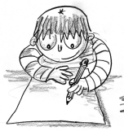
From the information paragraphs above, spend 5 minutes teasing out and separating the bits of evidence.
problems at home
seems unhappy
unenthusiastic
doctor centred consultations
poor patient feedback
patient complaints
find it difficult to receive positive or negative feedback
above average sick leave
always punctual
good documentation
does not prepare adequately for COT, CBD, tutorials
does not inform senior receptionist about leave till the last minute
makes me feel stressed
generally deals ok with paperwork and referrals
feels everyone is against her

You should get something like
this:

Step 2 – map the evidence to R, D, M and p
Instructions:
- Map each item on your evidence list to the RDM-p domains they may be related to. Use a table like the one below.
- Put a ‘+’ next to a positive marker and a ‘–’ next to negative ones.
- Use brackets to indicate weakly positive or negative indicators of a domain.
- Write some areas you want to explore further with the trainee in the last column.
In my example below, I have only marked the positive ones with a plus sign and assumed everything without a ‘+’ is a negative: looks less messy, is easier to absorb and is easier to interpret at a glance.

RDM-p category | The Evidence | Our reasoning/things we want to explore
M | Problems at home | Problems at home usually imply a difficulty in managing one's life.
M | Seems unhappy | Being unhappy usually means being unable to manage one's life and health. A poor work-life balance almost always leads to unhappiness. Maybe she’s unable to ‘track’ her own performance or health issues; an inability to ‘track’ is a management problem.
(M) p | Unenthusiastic | Someone who appears unenthusiastic about their work which involves dealing with people is likely to have a negative impact on others. It could also mean the doctor has a poor attitude in terms of their approach to work. Both of these are a professionalism issue.  But it could also be a management issue – maybe there’s so much else going on in their life. Failure to manage their life leads to stress and stress dampens enthusiasm.
R p | Doctor-centred consultations | A doctor-centred consultation says something about the doctor-patient relationship and possibly about the attitude of the doctor. Attitudinal problems always relate to professionalism.
R D p | Poor patient feedback and complaints | Poor patient feedback usually signals a relationship problem, but can also suggest a diagnostic problem (relating to perceived errors of judgment, missed cues etc.). It might also indicate that the attitude of the doctor needs looking at (professionalism).
M p | Difficulty accepting negative feedback | If a person finds it difficult to accept well-intentioned feedback, they may need to look at the value or respect they give to the opinions of more experienced colleagues (professionalism). Alternatively, it may be that they are uncomfortable with their performance being examined or sensitive to criticism (self-management), or that they find reflection difficult (management of learning).
M p | Above average sick leave | When a doctor takes above average sick leave it is usually an indication that they’re finding it difficult to manage other aspects of their life.  Alternatively, when a doctor seems to take sick leave almost randomly, without considering patients and colleagues, this may indicate a problem with professionalism.
M+ p+ | Always punctual, hardly ever late. | A punctual doctor is someone who obviously manages their time well.  When there is a strong positive or negative here (i.e. ‘always punctual’) this also suggests clear respect for the importance of keeping to time, and not keeping others waiting (professionalism).
M+ p+ | Very accurate and careful documentation | This doctor is managing her record keeping well and clearly respects its importance (professionalism).  As mentioned earlier, routine efficiency is not tagged as professionalism; that is simply doing one’s job. It’s only when the evidence indicates a strong positive/negative tendency (using words like ‘very’ or ‘always’) that one highlights it as professionalism. This is an important point to get clear in your mind.
M p | Does not prepare adequately for COT, CBD, tutorials | A doctor may not be preparing for tutorials because they are not managing their time well at home (being overwhelmed by other things). It might also indicate an underlying attitude problem in reference to their own learning and its importance (professionalism).
M p | Does not inform senior receptionist about leave until the last minute | Not informing senior reception staff about sick leave until the last minute clearly suggests problems with managing time (i.e. making a decision in a timely way), and possibly a lack of appreciation for the need for others to know early (professionalism).  If the trainee is taking leave at the last minute because they can’t prioritise and decide about things in their own life, then this becomes a diagnostic issue.
D M R | Makes me feel very stressed | This is an interesting one: you’ve got to figure out who’s got the problem – is it you (e.g. personality clash) or is it genuinely them?  If the trainee is not aware of how stressed she makes other people feel then this is a diagnostic problem. Clearly making someone else feel stressed is a relationship problem.  However, if the trainee could manage the various aspects and problems in her home/work life, perhaps she wouldn’t make others ‘feel’ the stress she is going through.
M+ | Generally deals with paperwork and referrals | Dealing with paperwork effectively means good management skills.  You might have thought that dealing with paperwork demonstrates a respect to its importance and therefore a positive indicator of professionalism. Earlier on we said general efficiency is routine, so not tagged as professionalism. And this one says ‘generally’ rather than always! Only an exceptional care/attention or a lack of it should be considered an indicator of professionalism.
D M R (p) | Feels everyone is against her | This one potentially fits all four categories. This trainee feels everyone is against her and this judgement (or conclusion) might be wrong (if so, a diagnostic problem). Clearly it also says something about the relationship between the trainee and others. And people who are finding it difficult to manage stressful problems at home often become irritable and sensitive to the extent they feel everyone is against them.  [If the trainee feels everyone is against her she may become defensive, and her approach (attitude) to work may then be affected (professionalism). However, if this was the case you would expect to find critical observations recorded about her manner, for instance (also under professionalism).]

Step 3 – create an Edwards’ diagnostic map (to capture and classify potential issues related to knowledge, skills and attitudes).
Don’t be scared of the Edwards’ diagram below: it gives you an ‘at a glance’ map view of where to focus the discussion. Map the elements from the table above to the diagram below (blank version at the end of this document). The brackets you used earlier to indicate weak positive or negative indicators will help you place them more precisely. Underline POSITIVE evidence to differentiate it from the negative.
RELATIONSHIP
DIAGNOSTICS
MANAGEMENT
PROFESSIONALISM
Above average sick leave
Sound paperwork/referrals
Not preparing for CBD, COT etc
Not informing about leave early
Patient complaints
Doctor centred consultations
Poor patient feedback
Feels everyone is against her
Always punctual
Very good documentation
Makes trainer feel v. stressed
Unable to accept feedback
Problems at home
Seems unhappy
Unenthusiastic
Step 4 – which RDM-p domains are causing concern?
Back to the Edwards’ diagram, and look at each domain in turn:
- First the green ‘Relationship’ box,
- Then the blue ‘Diagnostics’ circle
- Then the orange ‘Management’ box and
- Finally the red ‘Professionalism’ tennis ball shape.
- Where do most of the negative pieces of evidence lie?

In this particular example:
- Most of the items live in the orange and red areas. This tells us to focus our initial discussion primarily on Management and Professionalism. We need to test whether problems here are weakening performance in the two key face-to-face areas: Relationship and Diagnostics.
- There are fewer items in the other two remaining areas (green/Relationship and blue/ Diagnostics). Be careful though: it is risky to quantify significance here. For instance, patient complaints may be a huge issue summarised in one statement! So, at some point in our discussion, we will want to move on to discuss Relationship and Diagnostics to test whether there is some aspect of these two areas that might also be acting decisively (i.e. as a root cause) to weaken this trainee’s performance. In this particular case, we need to check how significant the patient complaints are and what the root of the doctor-centred consultations is.

Step 5 – Write down obvious internal and external factors (the I and E of SKIPE)
Write down any internal or external factors you need to bear in mind. Let’s say in this case all we know at this stage is that Alana has two young children. You’ll be able to add more during the discussion with the trainee as more personal details are shared with you.

Internal Factors? | External Factors?
 | Has two young children.

Step 6 – Write down obvious past factors (the P of SKIPE)
Consider briefly whether early influences (such as upbringing, cultural and educational roots) or more recent influences (such as their experiences in training practices and hospitals) might be playing a part in their current struggle.

Step 7 – Using the SKIPE framework discuss things with the trainee to complete the diagnostic phase

- What exactly have you found that causes you concern so far (in terms of RDM-p)?
- Go through each of the RDM-p domains causing concern one by one.
- For each one, FIRST consider whether there are underlying Skills or Knowledge deficiencies that need addressing (the initial ‘SK’ check). Discuss this with the trainee.
- Then review the IPE list (Internal Factors, Past Factors and External factors) with the trainee. Explore what is already on there. Is there anything else that’s missing?

Let’s say from our discussion that Alana tells us she is experiencing relationship problems with her partner and has a busy home schedule with two young children (and that she feels like a single mum). This fits nicely with what the Edwards’ diagram says – perhaps her struggle to manage her home situation means she is finding it difficult to manage her work situation; perhaps as a result of all the stresses she is unhappy, irritable, and unable to give her work the attention it needs (professionalism). This tells us that the root of the problem may be at home and that is where the focus of discussion and problem-solving should lie.

Step 8 – Formulate a functional management plan
RDM-p helps you classify the performance concern. SKIPE helps you to classify the causal and influential factors behind them. Having a clear and accurate enough classifying system (RMD-p & SKIPE) helps you pinpoint where the discussion (and problem-solving) needs to lie. This results in solutions and development plans that are more likely to make a positive difference.

- Discuss each issue in turn with the trainee
- How might a particular issue be addressed? Be S.M.A.R.T.
- Formulate a functional management plan. In RDM-p language this would amount to something like: ‘Relationship issues might be dealt with via...; Diagnostic issues via...; Management issues via...; Professionalism issues via...’.
- Summarise and check understanding
- Schedule a review date.

I hope that this worked example gives you a clear understanding of the RDM-p approach in the context of a GP trainee in difficulty. Hopefully, you will have realised that the RDM-p classification system not only helps with diagnosing what the problem is, but its assessment and the frame within which planning is then shaped. You are now in a position to try it out. A final word from the original published paper²:

The model brings a unifying clarity and commonsense meaning to what have previously been seen as rather disparate list of competencies or definitions. In particular, significant insights have been reached by a number of individuals who have explored their own performance through the model. Many trainers introduced to the model have also felt that it has given them an accessible language and structure for helping guide and support their trainees.

Highlighting key concepts of the RDM-p approach [Tim Norfolk’s words]
- Performance concerns begin with performance, not personality or health or work relationships (the latter may be the cause of the performance concern). The performance evidence is captured in overt behaviour: something an individual has said or done or not said or done. In other words, the demonstration of or failure to demonstrate skills in the three R, D and M performance areas. Filtering behaviour through RDM-p should be the first (diagnostic) step in any performance assessment. Too often folk jump on causes without a valid diagnosis of the precise nature of the problem itself. You have to start with the performance evidence, form a diagnosis of what's going wrong, search to explain this through causation, then explore management. Just as you do with patients.
- When exploring causation, you must start with an initial SK check. In other words, ‘Is there a skills and/or knowledge issue here?’ If you think about it, our strongest diagnostic evidence comes from visible behaviour. Visible behaviour is a direct glimpse at someone’s skills. You cannot perform skills without having some knowledge underpinning them. Thus we first assess how well the trainee is actually demonstrating the relevant Relationship, Diagnostic and Management skills. If there’s a problem, we then check whether the trainee knows enough to be able to demonstrate those skills; things like how well they understand what the specific skills are in the first place, and how, when and where to use them!
- Sometimes the 'SK' is enough to account for the problem: not knowing something or not being able to articulate or activate a particular skill has led to problems. Thus poor skills or knowledge might be the exclusive diagnosis of both the problem and its cause – ‘he doesn’t acknowledge a patient’s struggle because he wasn’t aware that this might be appropriate.’ So all that’s needed might be a straightforward, practical, self-contained entry in his PDP. That's why SK should always be the first point of analysis - to ensure evidence is properly grounded. Only after an SK analysis do you check that all is ok with other potentially causal factors (e.g. attitudes, health & external factors), much as you might ask a patient 'how things are otherwise' when your initial diagnosis is clearly focused on their leg pain.
- Sometimes the problem will lie in an individual’s attitudes to aspects of their work in one or more RDM areas (i.e. the relative importance they attach to relationships, roles and tasks). This can be a sole problem but more often is in addition to the deficiencies identified with the ‘SK’ elements. If it is a sole problem – then they clearly have the required 'SK' but don't use them appropriately in some situations (e.g. through lack of effort or attention or respect). This is captured in the 'p' of RDM-p.
- It is an on-going point of contention whether or not attitudes can be 'seen' (overt) and are thus measurable as evidence. I always analyse attitudes very deliberately after the 'SK' evidence, because they inform behaviour rather than represent it. But in the end it's a circular argument as to whether attitudes are part of the diagnosis or the cause, and for your purposes it's really the sequence that's important rather than the semantics. Either way, attitudes are always grouped with skills and knowledge as the three overarching competency domains within which performance criteria are written (usually spoken of as ‘KSA’s). They constitute the bedrock of all evidence-based performance assessment, and that's why RDM-p defines the three together, while at the same time separating the 'p' from the 'RDM'...
- Then there are other causal factors to be considered (the IPE of SKIPE): Internal factors (in essence personality & health), Past factors (in personal & professional lives) and External factors (at work & outside work).
Closing observations from Tim Norfolk [in personal communication]

GPs tend to assess patients initially on ‘intuitive’ pattern recognition. This is fine in principle, provided a GP has the knowledge, training and experience. The key is getting the balance right between this initial recognition (the ‘gut feeling’) and confirmation through evidence (i.e. being alert for contradictory symptoms and signs).

The same should apply when dealing with GP trainees in difficulty. The problem is that most GPs don't have sufficient training or experience in the day-to-day assessment of doctors to risk relying on 'hunches'. Hence one sometimes hears loose and faintly prejudicial talk, based on questionable assumptions drawn from limited but weary experience. If you think about it, compare the number of trainees a GP might have trained with the number of patients seen - more patients in a day than trainees in a lifetime! And assessment often based on a few days' specific preparation to be a GP trainer as opposed to 8+ years of medical training. This is why I encourage trainers to be very deliberate in their approach to analysing performance, and why I've encouraged them to view assessment of their trainees in much the same holistic way as they would their patients. But to bring an additional rigour and care to the process, because of their relative lack of experience in handling such assessment, and the associated risks of making early assumptions. Without that rigour any complex analytical process is put at unjustifiable risk.

If TPDs or trainers don't routinely start analysing performance problems through RDM-p or comparable diagnostic ‘maps’, where is the reliable, evidence-based entry point to the discussion with the individual and onwards? If a problem has been highlighted, it must be possible to describe this in behavioural terms (i.e. something or a pattern of things said or done, which cause concern). There's the basic evidence. Everything else must surely be built on that reliable base. In fact my particular approach (RDM-p + SKIPE) or any comparable one would collapse the moment anyone opened analysis through discussion of causes rather than diagnosis of the actual presenting problem - as you would argue very clearly in relation to clinical practice.

I fully recognise the desire for a ‘clear & simple’ model which uses accessible language for TPDs and trainers to work from. And I’m very aware that my approach (i.e. RDM-p + 'SKIPE') is both detailed and multi-layered. But for me this is the ‘cost’ of ensuring a proper understanding of an individual’s struggle, and a far greater cost is potentially paid if that understanding is not achieved. Once again, the parallel with patients is self-evident.

In truth I've been reluctant all along to get drawn into a public definition of the process I follow in analysing the performance of doctors in difficulty, especially when seeking to identify causes. Why? Because this is so dependent on individual presentations (as with patients), and is so dynamic that any terminology (such as SKIPE) can only serve as the two-dimensional backdrop to a highly 'mobile', holistic analysis of a particular story. But a backdrop is nonetheless essential – and needs to be both rational and defensible. Hence RDM-p, hence SKIPE…

Tim Norfolk, 24th May 2011
Blank RDM-p Templates
Guidance:
- Formulate an evidence list.
- Map each item on your evidence list to RDM-p domains they may be related to.
- Put a “+” next to positive items and a “–” next to negative ones.
- Use brackets to indicate weakly positive or negative indicators of a domain.
- Write some areas you want to explore (in the discussion) in the last column.

RDM-p category | The Evidence  ( = comments or observed behaviour) | Your reasoning/areas you want to explore
Example  M- p-  M+ p+ | Example  Does not inform senior receptionist about leave until the last minute  Very accurate and careful documentation | Example  Is this a problem with managing time (i.e. making a decision in a timely way), and/or not appreciating the need for others to know early (professionalism)?  Manages records & respects its importance (professionalism).

Edwards’ Diagnostic Map for RDM-p
Map the elements from the evidence table above into the diagram below (type in the blue boxes - click and drag to rearrange them). The brackets you used earlier to indicate weak positive or negative indicators will help you place them more precisely. Underline POSITIVE evidence to help differentiate it from the negative.
RELATIONSHIP

DIAGNOSTICS
MANAGEMENT
PROFESSIONALISM
- Look at each domain shape in turn: which R, D, M and p themes dominate?
- Then explore these with the trainee using ‘SKIPE’

SKIPE

Skills  What deficient skills may be contributing to the difficulty? |  | Knowledge areas  Are there any deficient knowledge areas contributing to the difficulty?
Internal Factors  Any internal factors influencing the difficulty | Past Factors  Any past factors maintaining the difficulty? |  | External Factors  Any external factors contributing to the difficulty?

References
  - The National Clinical Assessment Service (NCAS) www.ncas.npsa.nhs.uk
  - In Quality in Primary Care. 2009;17(1):37-47. A unifying theory of clinical practice: Relationship, Diagnostics, Management and professionalism (RDM-p). Norfolk T, Siriwardena AN.
  - Dealing with Difficult Doctors, Jennifer King, BMJ Career Focus 2002;325:43 (10 August)
  - Games People Play: The Psychology of Human Relationships (Paperback) by Eric Berne, 2010 (Penguin)
  - TA Today : A New Introduction to Transactional Analysis (Paperback) by Ian Stewart and Vann Joines, 1987 (Lifespace publishing)

Any suggestions or amendments…

Please email me on rameshmehay@googlemail.com

Space for your notes...

